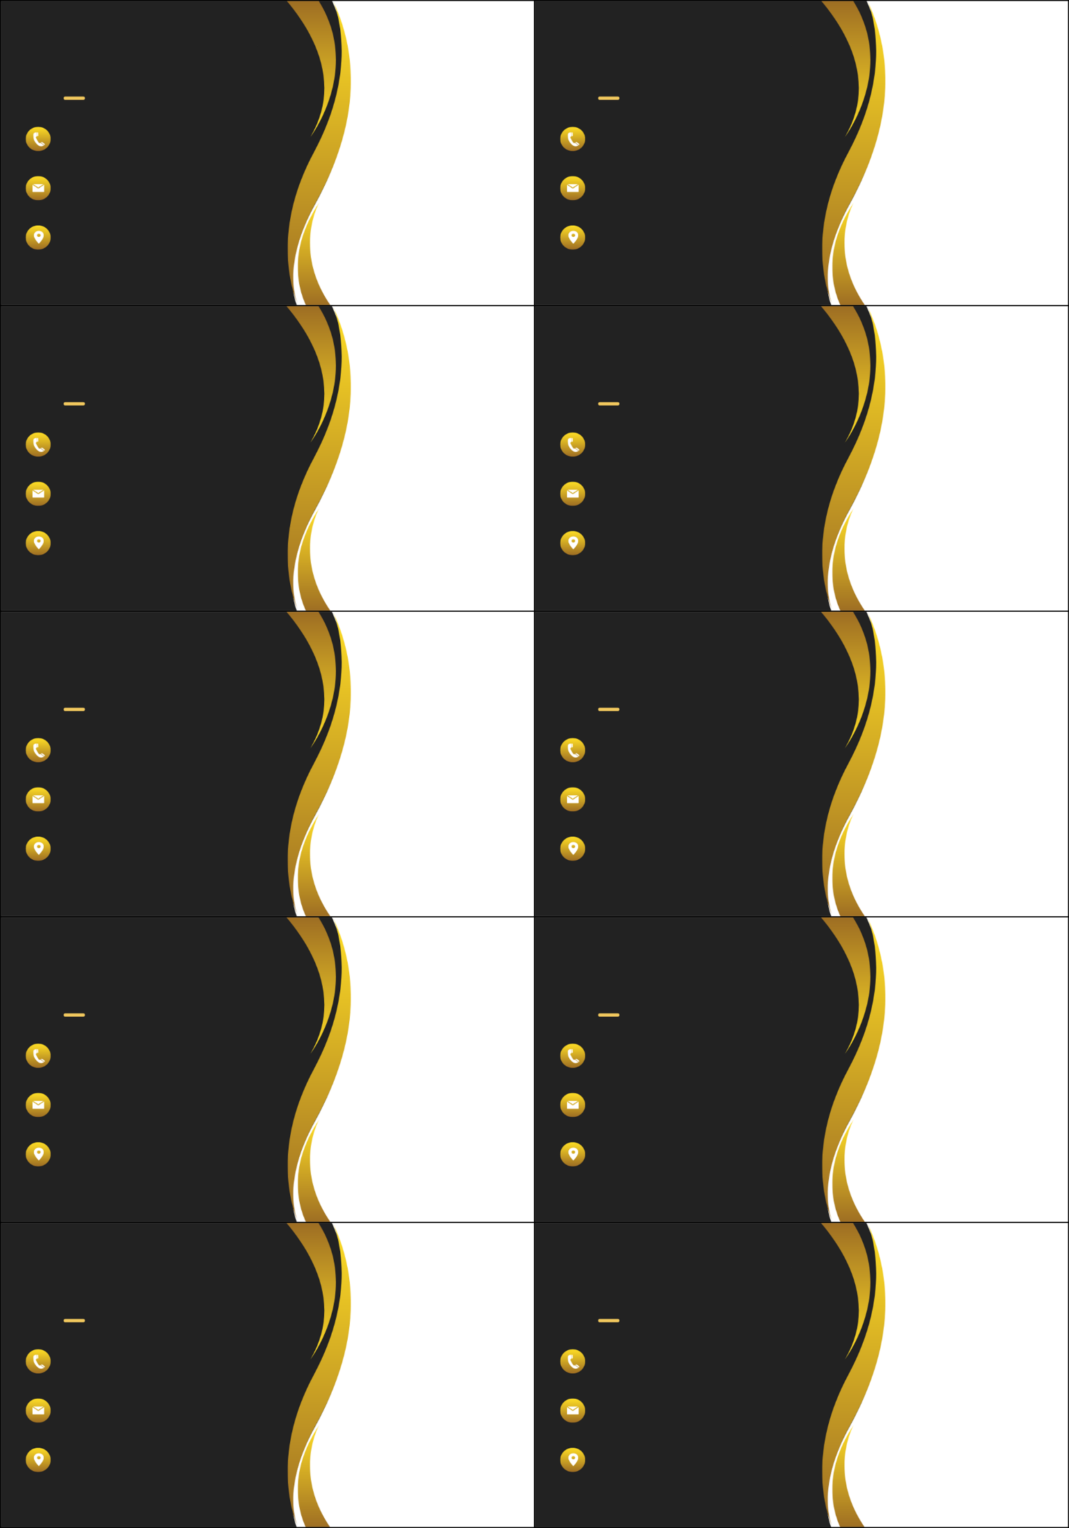

SABRINA TRENT

Site Manager

+123-456-7890

+123-456-7890

email@website.com

website.com

ST 12345

1234 Main St, City

SABRINA TRENT

Site Manager

+123-456-7890

+123-456-7890

email@website.com

website.com

ST 12345

1234 Main St, City

1234 Main St, City

ST 12345

website.com

email@website.com

+123-456-7890

+123-456-7890

Site Manager

SABRINA TRENT

1234 Main St, City

ST 12345

website.com

email@website.com

+123-456-7890

+123-456-7890

Site Manager

SABRINA TRENT

1234 Main St, City

ST 12345

website.com

email@website.com

+123-456-7890

+123-456-7890

Site Manager

SABRINA TRENT

1234 Main St, City

ST 12345

website.com

email@website.com

+123-456-7890

+123-456-7890

Site Manager

SABRINA TRENT

1234 Main St, City

ST 12345

website.com

email@website.com

+123-456-7890

+123-456-7890

Site Manager

SABRINA TRENT

1234 Main St, City

ST 12345

website.com

email@website.com

+123-456-7890

+123-456-7890

Site Manager

SABRINA TRENT

1234 Main St, City

ST 12345

website.com

email@website.com

+123-456-7890

+123-456-7890

Site Manager

SABRINA TRENT

1234 Main St, City

ST 12345

website.com

email@website.com

+123-456-7890

+123-456-7890

Site Manager

SABRINA TRENT