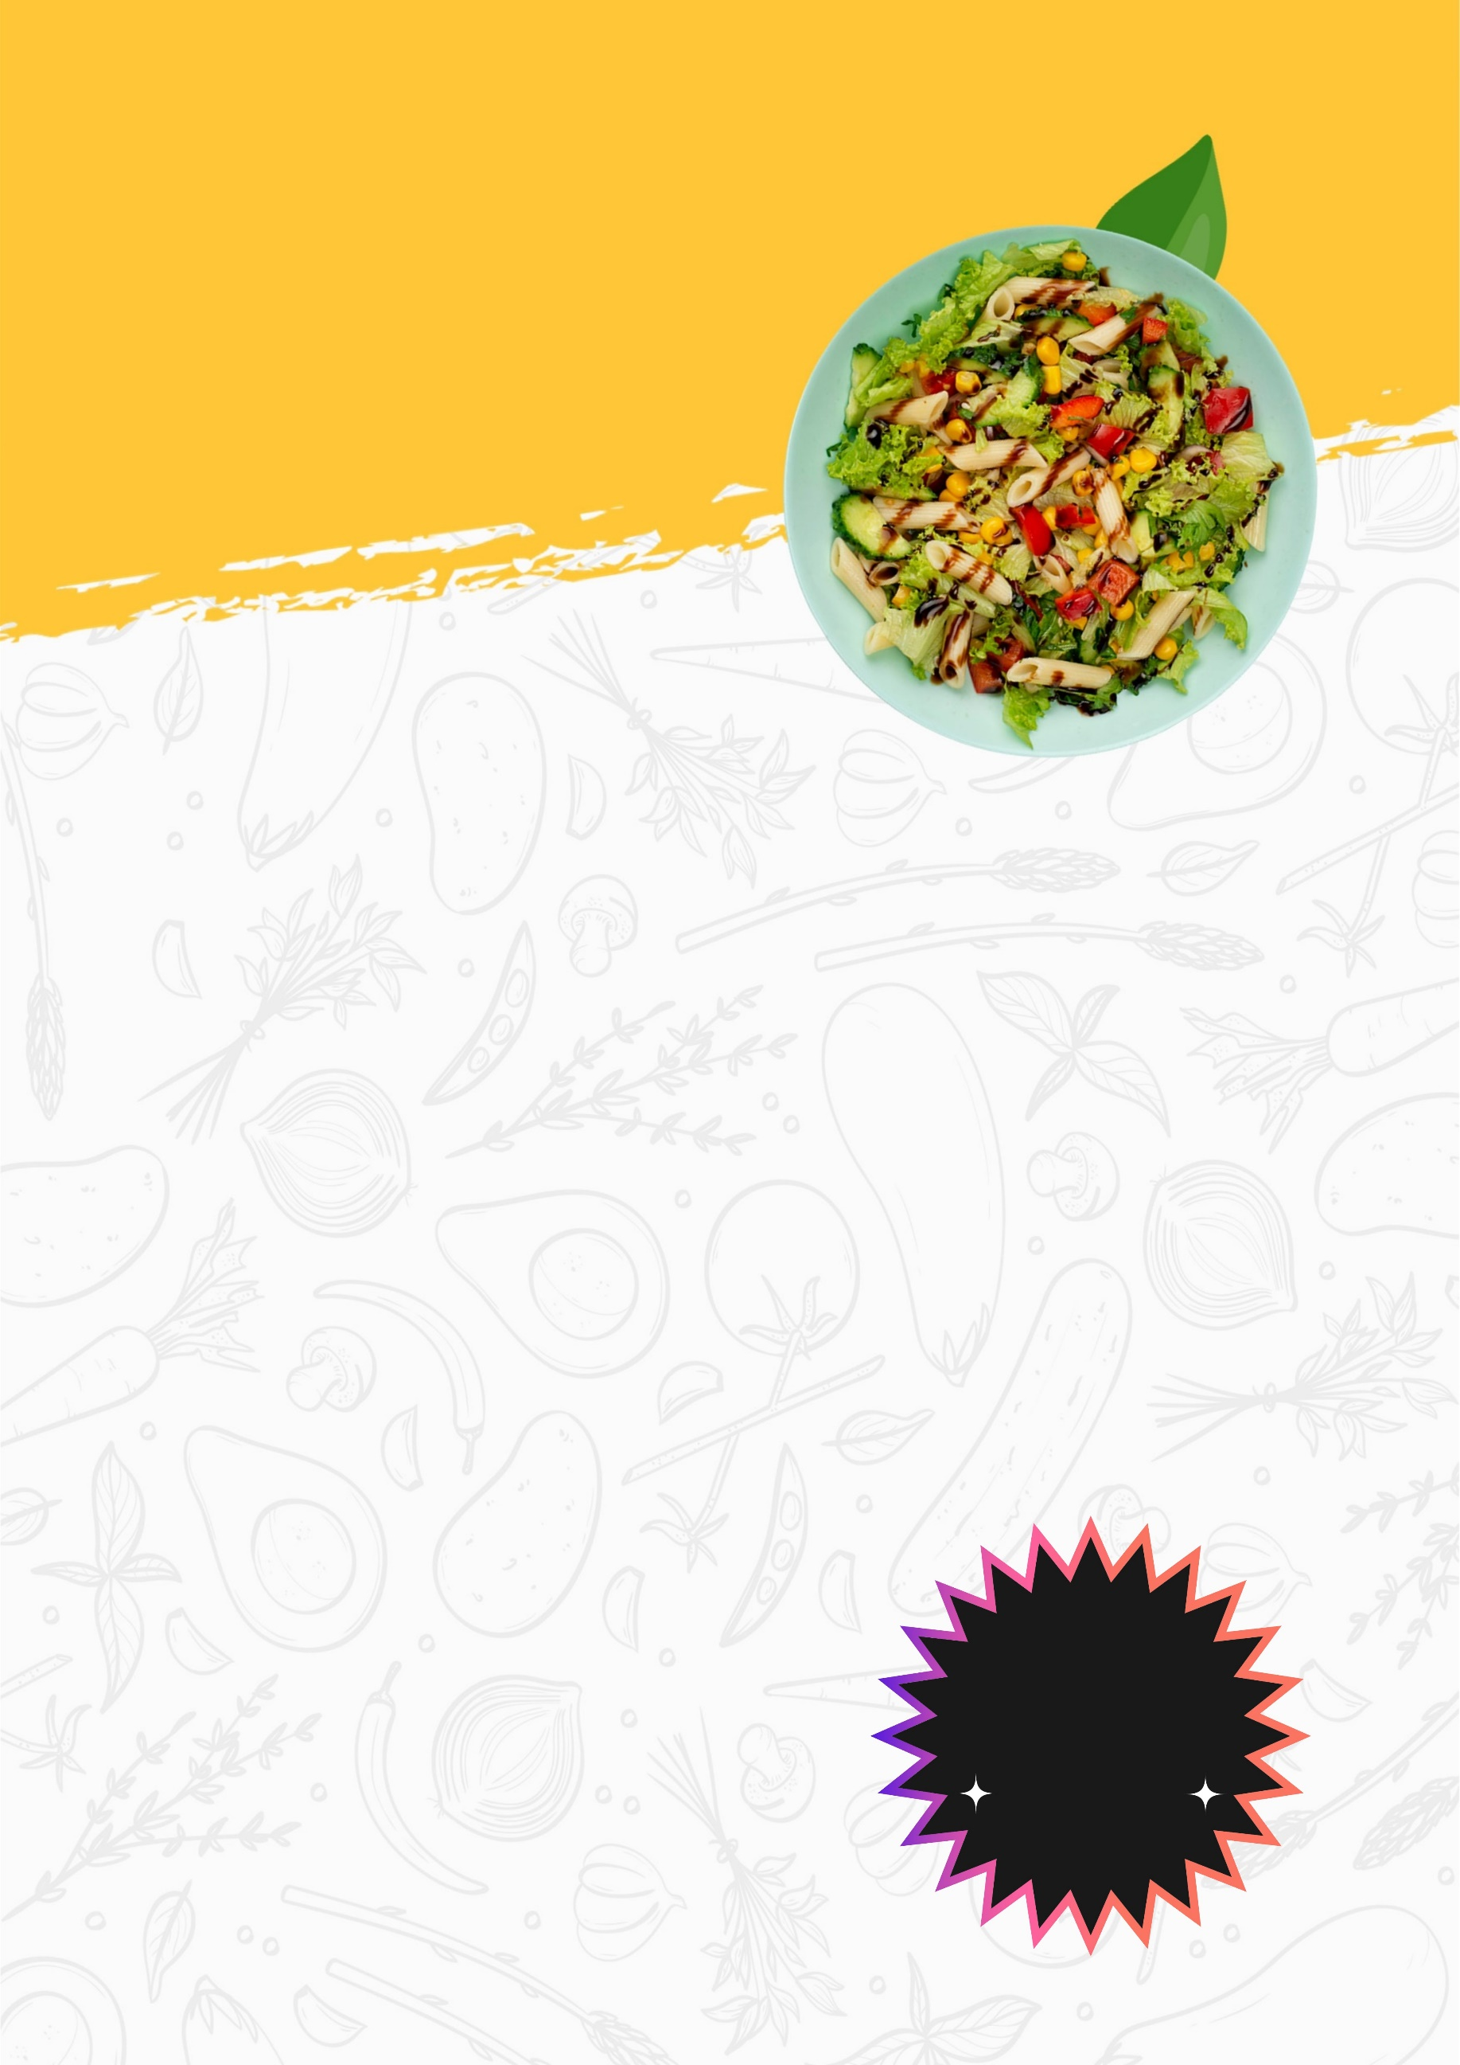
FOOD STORE
Sunday, 21 August
Street Address, Number, Instructions
Please bring: [Name and contact info]
RSVP TO: Click here to enter text

YOU’RE INVITED TO CELEBRATE WITH US!

SALE

40%

OFF

