  FITNESS  IS FIRST |  |  |  | MONDAY TO SATURDAY  6am to 10am and 5pm to 10 pm

OUR SERVICE
 |  | 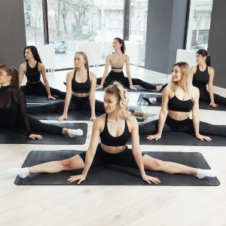 |  |  |  | 
Exercise |  | Yoga |  |  |  | Zumba

MEMBERSHIP
3 Months  Edit text |  | 6 Months  Edit text |  |  |  | 12 Months  Edit text

BENEFITS
Edit text |  | Edit text |  |  |  | Edit text
 | Name |  | Email |  |  |  | Phone

