
Food

How is work
 |  |  |  | 
Add text |  | Add text |  | Add text
Add text |  | Add text |  | Add text

Best Seller
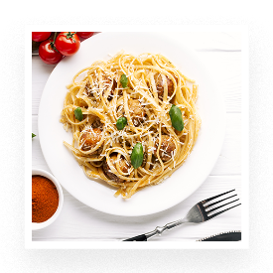 |  |  |  | 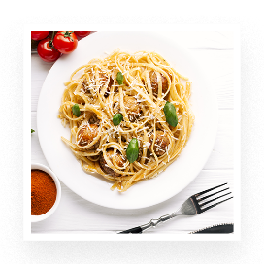

BENEFITS
Edit text |  | Edit text |  | Edit text
 | Phone |  | Email |  | Website

